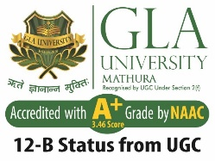 **ACFP 2025**

**4th International Conference on**

**“Advancement in Core**

**and Frontier of Physics**

**(ACFP-25)”**

**In Hybrid Mode**

**Organized by**

**Department of Physics**

**GLA Photo**

**Publication Partner**

**Scopus**

**Wave of Science**

**Index Journal**

**Team ACFP-25**

**E-mail:**

**For Conference Queries:**

**Dr. B.K. Singh: +91-9358880465**

**Dr. Raj Pal Singh: +91-9857259533**

**Dr. Lokesh Kumar Sharma: +91-8393941681**

**About ACFP-25**

Department of Physics, GLA University, Mathura, U.P., India is going to organize the 4th International Conference on Advancement in Core and Frontier of Physics (ACFP-25) during November 1-2 2025 in Hybrid Mode. The aim of this conference is to bring together researchers, academicians, scientists, scholars, and research organizations around the world to discuss and present papers on recent developments in the broad fields of Physics. The ACFP-25 will provide a premier interdisciplinary platform for a great gathering of academic professionals from all over the world in the varius fields of Physics. It will provide a major forum to exchange knowledge on the most recent innovations, trends, and concerns, as well as practical challenges encountered and solutions adopted in the various fields of Physics. The conference will have a broader view of Physics at a single platform and will cover experimental, theoretical and phenomenological aspects.

**About Organizing Institute**

GLA University is one of the premier universities in Northern India. The university was established in 1998 as an institute by our present Chancellor, Shri Narayan Das Agrawal and later on got the status of University in 2010. The Chancellor envisioned GLA University as a quality education institute to serve the needs of higher education for the youth of the region and beyond. Recently the University has been accredited with A+ grade by NAC. It spreads across 130 acres of land and is home to more than 23,000 students, enrolled in a variety of professional courses.

It boasts of well-designed and maintained buildings, contemporary laboratories, spacious residential complexes and recreational facilities. The facilities of such kind and grandeur make the GLA campus one of the best in the region, providing its students an ideal environment to hone their skills in an increasingly competitive and demanding world.

**About the Department**

Under the banner of GLA University, the Department of Physics is constantly and consistently working to achieve core objectives of the university. Department facilities state of art laboratories where students can realize their ideas into tangible objects in terms of concepts in various fields of Physics. The department has state of Art laboratories for UG and PG students.

Department is consistently delivering high quality research. Faculty members of the department are highly qualified and extending their expertise in academics and research. The department of Physics blossoms with the specialized technical and professional excellence and as on date it has developed into a pillar of strength of GLA University. In order to cater the need of skilled professionals the department is serving B.Tech and offering B.Sc. (H), M.Sc. and Ph.D. programs in Physics.

**Chief Patron**

**Shri. Narayan Das Agrawal**

Hon’ble Chancellor

GLA University, Mathura,

India

**Co-Chief Patron**

**Prof. Durg Singh Chauhan**

Advisor to GLA University, Mathura

India

**Patrons**

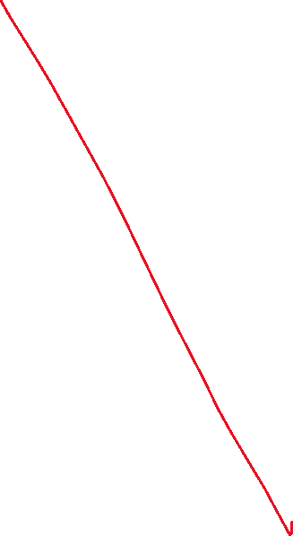

**Prof. Anup Kumar Gupta**

Vice Chancellor, GLA University, Mathura

India

**Prof. Phalguni Gupta**

Advisor to Chancellor, GLA University, Mathura

India

**Steering Committee**

**Shri. Neeraj Agrawal**

CEO, GLA University, Mathura, India

**Shri. Vivek Agrawal**

CFO, GLA University, Mathura, India

**Mr. Ashok Kumar Singh**

Registrar, GLA University, Mathura, India

**Prof. Ashish Sharma**

Dean of Academic Affairs,

GLA University, Mathura

**Prof. Kamal Sharma**

Dean, Research & Development,

GLA University, Mathura

**International Advisory Committee**

1. Prof. Salvatore Capozziello

Università di Napoli "Federico II", Nepoli, Italy

1. Prof. Giogia Kaniadakis

Professor of Theoretical Physics - [Politecnico di Torino](https://scholar.google.it/citations?view_op=view_org&hl=it&org=8140382647356866723) – Italy

1. Prof. Sergei D. Odintsov

ICREA Research Professor, ICREA, Barcelona and ICE(CSIC-IEEC), Barcelona

1. Prof. Hooman Moradpour

Research Institute for Astronomy and Astrophysics of Maragheh (RIAAM) in Maragheh, Iran,

1. Prof. M. Hayakawa

Hayakawa Institute of Seismo Electromagnetics, Co., Ltd. (Hi-SEM) &

The University of Electro-Communications, Advanced Wireless and

Communications Research Center, Tokyo, Japan

1. Prof. Sushil Kumar

Director Research

School of Information Technology,

Engineering, Mathematics, and Physics

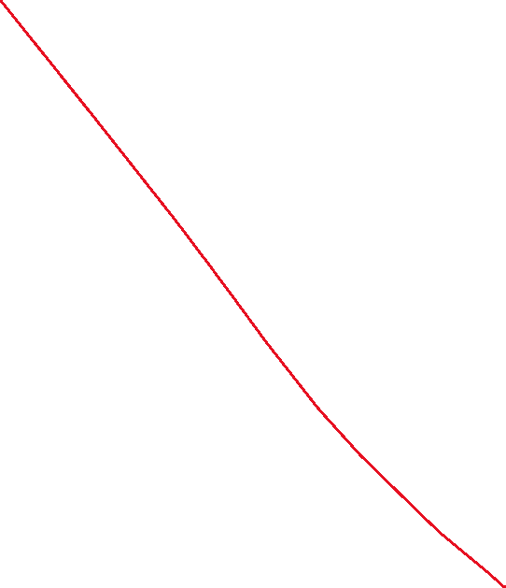

The University of the South Pacific

Suva, Fiji

1. Prof. R. P. Singh

Department of Physics

Schmid College of Science,

Chapman University, USA

1. Prof. Luis Herraera
2. Prof. Maxim Khlopov

Institute of Astroparticle physics, APC, France and NRNU MEPHI, Russia

1. Prof. Rogerio Riffel

Department of Astronomy

Institute of Physics, Federal, University of Rio Grande do Sul (UFRGS)

1. Prof. Katsumi Hattori  
    Graduate School of Science, Chiba University  
    1-33, Yayoi, Inage-ku, Chiba, 263-8522
2. Prof. Yasuhide Hobara

Department of Communication Engineering and Informatics,

The University of Electro-Communications

1-5-1 Chofugaoka, Chofu, Tokyo 182-8585

1. Prof. Kazuharu Bamba

Division of Human support system,

Faculty of Symbiotic systems

Science, Fukushima University, Japan

1. Prof. Andrew De Benedictis, Canada
2. Dr. Vinay Sharma

Senior Development Engineer,

Bosch GmbH,

Germany

**National Advisory Committee**

1. Prof. Varun Sahni, IUCCA, Pune
2. Dr. D. K. Mohapatra

Outstanding Scientist and Head,

Safety Research Institute (SRI) & Southern Regional Regulatory Centre (SRRC),

Atomic Energy Regulatory Board,

IGCAR Campus, Kalpakkam

1. Prof. B.K. Patra,

Department of Physics,

IIT, Roorkee

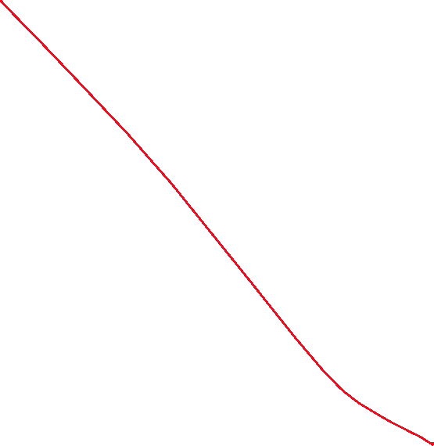

1. Prof. Rajiv Ranjan,

Department of Physics,

IISc, Bangalore

1. Prof. Gopi K. Seemala*,*

Indian Institute of Geomagnetism   
Plot No. 5, Sector 18, Panvel (west)

Navi Mumbai – 410218

1. Dr. Arun Kumar Upadhyay

Senior Principal Scientists

National Physical Laboratory

New Delhi

1. Dr. B.K. Sahoo  
   Scientific Officer (G)  
   Radiological Physics and Advisory Division  
   Bhabha Atomic Research Center,  
   CTCRS Building, Room No: 205,  
   Anushaktinagar, Mumbai-400 094
2. Prof. Prasanna Mishra,

Scientist at SAG, DRDO,

North Delhi

1. Prof. Savita Dixit,

Department of Chemistry,

MANIT, Bhopal

1. Prof. Farooq Rahman,

Department of Mathematics

Jadavpur University, Kolkata

1. Dr. Sanjay Kumar Srivastava

Principal Scientist,

National Physical Laboratory

New Delhi

1. Dr. B.K. Sapra  
   Outstanding Scientist  
   Head, Radiological Physics and Advisory Division  
   Bhabha Atomic Research Centre  
   CT&CRS Building, Anushaktinagar  
   Mumbai – 400094
2. Prof. Mohammed Shami

Former Director of ICTP, Jamia Millia Islamia,

Presently Director of CCSP, SGT University,

Gurugram

1. Prof. Anil Kumar Yadav, Principal,

UCER,

Greater Noida

1. Prof. Saibal Ray,

Associate Director, CCASS, GLA University, Mathura

1. Dr DK Aswal

Director,

Health Safety & Environment Group

BARC, Mumbai



1. Dr. Mukesh Jewariya

Senior scientists,

National Physical Laboratory

New Delhi

1. Prof. Bivudutta Mishra,

Department of Mathematics,

BITS, Pilani

1. Prof. Aloke Kanjilal,

Department of Physics, School of Natural Science

Shivnadar Institute of Eminaence,

Delhi-NCR, Gautam Buddha Nagar,

Greater Noida

1. Prof. Akhileswar Prasad Singh

Professor, Department of Physics

University of Delhi, New Delhi

1. Prof. O.P. Thakur

Professor, Department of Physics

Netaji Subhas University of Technology,

New Delhi

**Local Organizing Committee**

* **Prof. Anuj Vijay, GLAU, Mathura, India**
* **Prof. R.P. Singh, GLAU, Mathura, India**
* **Prof. Minika Goyal, GLAU, Mathura, India**
* **Dr. Benoy Kumar Singh, GLAU, Mathura, India**
* **Dr. Lokesh Kumar Sharma, GLAU, Mathura**
* **Dr. Manoj Kumar Singh, GLAU, Mathura, India**
* **Dr. Rashmi Singh, GLAU, Mathura, India**



* **Dr. Dharm Veer Singh, GLAU, Mathura**
* **Dr. Saptarshi Pal, GLAU, Mathura**
* **Dr. Aradhya Kumar Shukla, GLAU, Mathura**
* **Dr. Amit Kumar Chauhan, GLAU, Mathura**
* **Dr. Shobhit Sachan, GLAU, Mathura**
* **Dr. Mrinal Jauhari, GLAU, Mathura**
* **Dr. Vipul Bhardwaj, GLAU, Mathura**
* **Dr. Gyanendra Kumar Maurya, GLAU, Mathura**
* **Dr. Sukriti, GLAU, Mathura**
* **Dr. Swati Singh, GLAU, Mathura**
* **Dr. Vijay Kumar Mishra, GLAU, Mathura**

**Organizing Chair**

**Prof. Anuj Vijay**

Head, Department of Physics

GLA University, Mathura

**Convener**

**Dr. B.K. Singh**

Associate Professor, Department of Physics,

GLA University, Mathura

**Prof. Raj Pal Singh**

Professor, Department of Physics,

GLA University, Mathura

**Organizing Secretary**

**Dr. Lokesh Kumar Sharma**

**&**

**Dr. Saptarshi Pal**

Assistant Professor, Department of Physics,

GLA University, Mathura

**Co-Covenor**



**Prof. Monika Goyal**

Professor, Department of Physics,

GLA University, Mathura

**Joint Secretary**

**Dr. Vipul Bhardwaj**

Department of Physics,

GLA University, Mathura

**Dr. Gyanendra Kumar Maurya**

Department of Physics,

GLA University, Mathura

**Conference Tracks**

**Track1**: Nuclear and High Energy Physics

**Track2**: Cosmology and Modified Theory of Grativity

**Track3**: Plasma Physics and Optics

**Track4**: Modeling and simulation studies

**Track5**: Seismo-electromagnetics and Atmospheric Science

**Track6**: Material Science

**Publication**

All the accepted paper will be published in Scopus/WoS conference proceedings as per quality norms of the publisher.

The full length paper can be submitted through

**Conference email: __________**

**Or through: _____________**

**Important Dates**

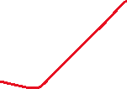

|  |  |
| --- | --- |
| Conference Date | November, 1-2, 2025 |
| Registration Starts | June 15, 2025 |
| Registration Ends | October 15, 2025 |
| Submission of Full  Length Paper Starts | November 15, 2025 |
| Submission of Full  Length Paper Starts | December 15, 2025 |

**Registration Fee**

The registration fee is given below for your reference:

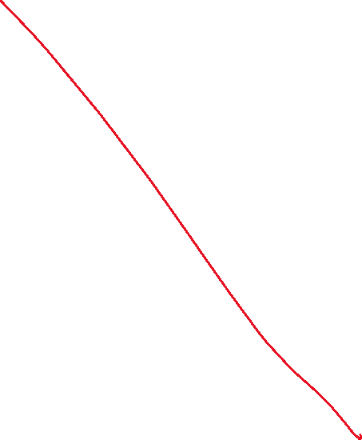

|  |  |
| --- | --- |
| Category | Amount of Fee |
| International  Participants | USD 100 |
| Acadmicians | INR 1500/- |
| Students | INR 1200/- |
| Corporate Executive  And Professionals | INR 3000/- |

The authors agree that if the paper is accepted, at least one of the authors will register for conference to present the paper.

**Registration link:**

**Payment Details:**

Mode: Online Payment

Beneficiary Name: ____________

Workshop Account: __________

Current A/C No.__________

IFSC Code: ____________

Branch Name: __________